Partial-Point-Supervised Segmentation on LoveDA
Technical Report — Findings So Far
Author: Meer Muhammad
Dataset: LoveDA (Kaggle) | Model: U-Net + ImageNet-pretrained ResNet-34 | Loss: Partial Cross-Entropy

1. Problem Statement
Standard segmentation models require a complete pixel-level mask for every training image. This project instead simulates training with sparse point annotations — a small number of labeled pixels per image rather than a dense mask — which is far cheaper to collect but provides very limited supervisory signal.
The work consists of three parts: (1) implement Partial Cross-Entropy (pCE) loss, which trains only on pixels carrying a point label; (2) apply it to a real remote sensing segmentation dataset by simulating point labels from existing full masks; and (3) run experiments exploring factors that affect performance.

2. Method

2.1 Dataset
LoveDA (Land-cover Domain Adaptive semantic segmentation), accessed via Kaggle. It contains 1024x1024 RGB images of Urban and Rural scenes across 7 land-cover classes, plus a no-data/ignore class (0).
Split | Images
Train | 2,522
Val | 1,669
Test (no masks, excluded) | 1,796

Class distribution (sampled from 200 training masks):
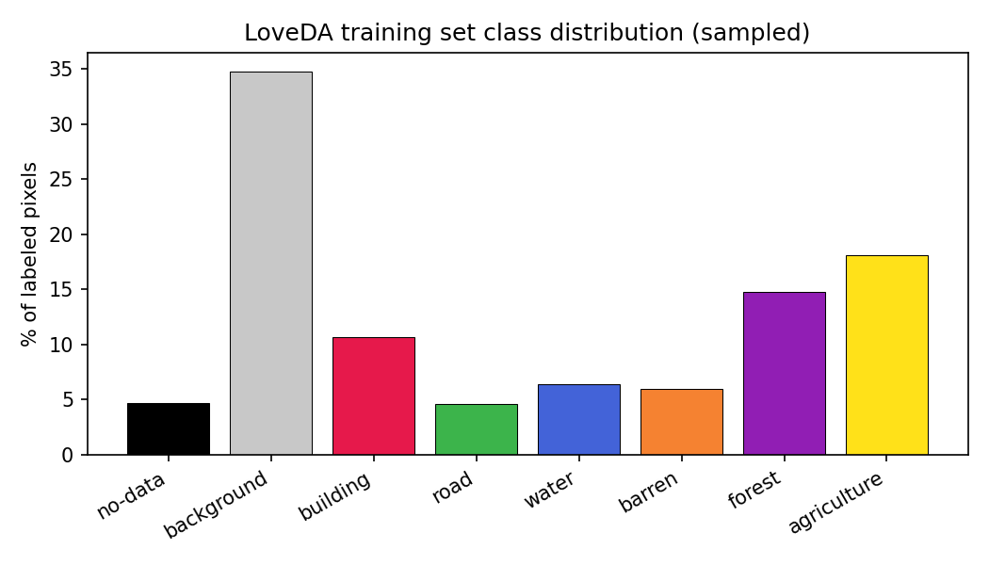
The dataset is meaningfully imbalanced: background dominates at 34.7% of pixels, while road (4.6%) and no-data (4.7%) are the smallest categories. This imbalance directly motivates the sampling-strategy experiment below.

2.2 Point-label simulation
Given a full ground-truth mask, a sparse point-label mask is generated using one of two strategies, both excluding the no-data class:
- Random: uniformly sample N pixels from all valid (non-no-data) pixels in the image.
- Class-balanced: sample K points from every class present in the image, guaranteeing coverage regardless of class size.
For a fair comparison between strategies, the random budget N is set to match the average total labeled-pixel count that class-balanced sampling produces at a given K, measured empirically per configuration.

2.3 Partial Cross-Entropy Loss
pCE = sum( CE(pred, GT) * MASK_labeled ) / sum(MASK_labeled)
Standard per-pixel cross-entropy is computed, multiplied by a binary point-label mask, and normalized by the number of labeled pixels rather than the total pixel count. Unlabeled pixels (including no-data) receive exactly zero gradient. This was implemented as a PyTorch nn.Module and separately verified in NumPy: with a full mask it is numerically identical to standard mean cross-entropy, and its analytic gradient matches a finite-difference check to ~1e-8.

2.4 Model & training setup
U-Net with an ImageNet-pretrained ResNet-34 encoder (transfer learning), trained with Adam (lr=1e-4) and the PartialCELoss above. Images and masks are resized from 1024x1024 to 512x512; masks use nearest-neighbor interpolation to preserve integer class labels (an earlier run used default bilinear mask interpolation, which was identified and corrected before the experiments reported here). All experiments use 10 training epochs unless noted otherwise, with mean IoU (excluding the no-data class) as the evaluation metric on the full validation masks.

3. Experiment: Random vs. Class-Balanced Point Sampling

Purpose / Hypothesis
At a fixed, small labeling budget, class-balanced sampling was hypothesized to outperform random sampling, because random sampling can by chance omit rare classes (e.g. road at 4.6% of pixels) entirely, starving them of gradient signal under pCE loss. The gap was expected to shrink as budget grows, since random sampling becomes more likely to cover every class on its own.

Experimental Process
Two budget levels were tested. At each level, a class-balanced model and a random-sampling model were trained from scratch (identical architecture, optimizer, and epoch count), with the random budget matched to the empirically measured average labeled-pixel count of the balanced condition:
Budget level | Balanced setting | Random setting | Avg. labeled px/image
Tight | 2 points/class | 10 random points | ~9.7
Moderate | 5 points/class | 24 random points | ~24.0

Results — Moderate budget (~24 px/image)
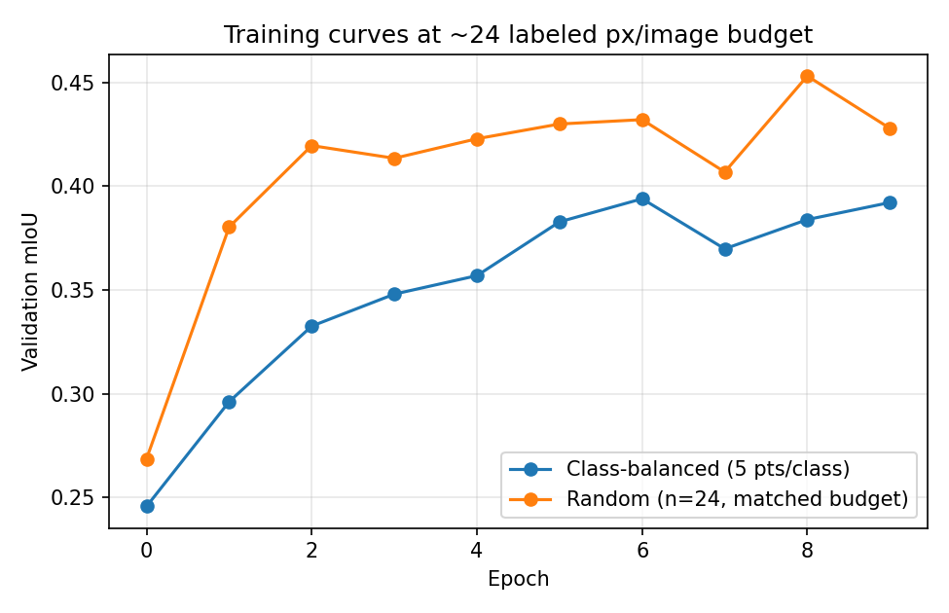
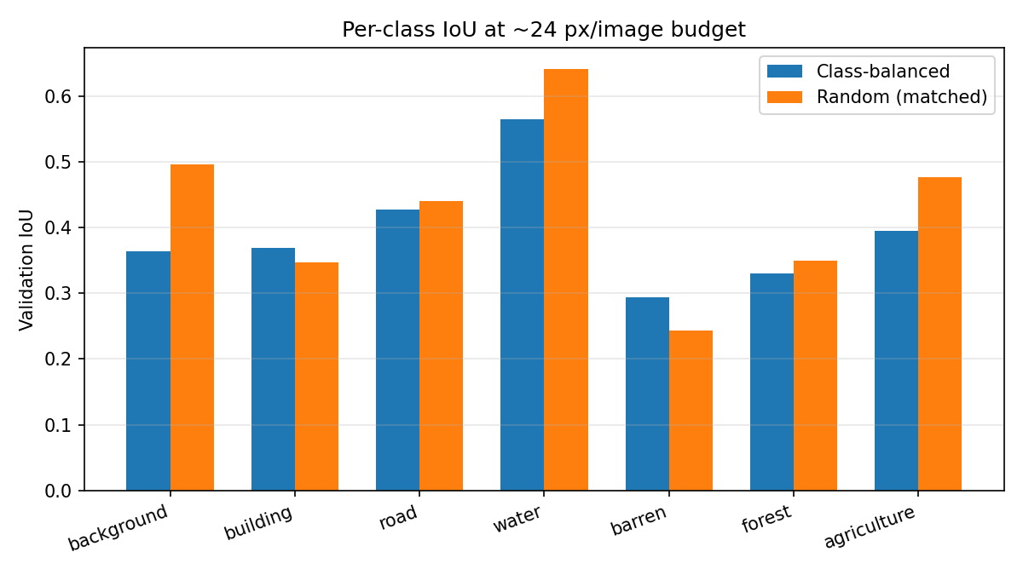
Class | Balanced IoU | Random IoU | Difference (Random − Balanced)
background | 0.3641 | 0.4954 | +0.131
building | 0.3692 | 0.3473 | -0.022
road | 0.4276 | 0.4405 | +0.013
water | 0.5647 | 0.6414 | +0.077
barren | 0.2937 | 0.2437 | -0.050
forest | 0.3301 | 0.3500 | +0.020
agriculture | 0.3955 | 0.4762 | +0.081
Mean | 0.3921 | 0.4278 | +0.036

Results — Tight budget (~10 px/image)
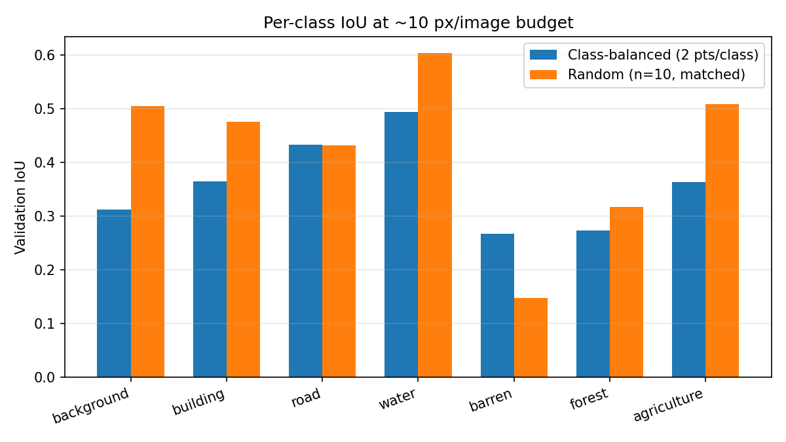
Class | Balanced IoU | Random IoU | Difference (Random − Balanced)
background | 0.3123 | 0.5049 | +0.193
building | 0.3639 | 0.4756 | +0.112
road | 0.4331 | 0.4317 | -0.001
water | 0.4937 | 0.6037 | +0.110
barren | 0.2672 | 0.1477 | -0.120
forest | 0.2724 | 0.3172 | +0.045
agriculture | 0.3634 | 0.5085 | +0.145
Mean | 0.3580 | 0.4270 | +0.069

Summary across budgets
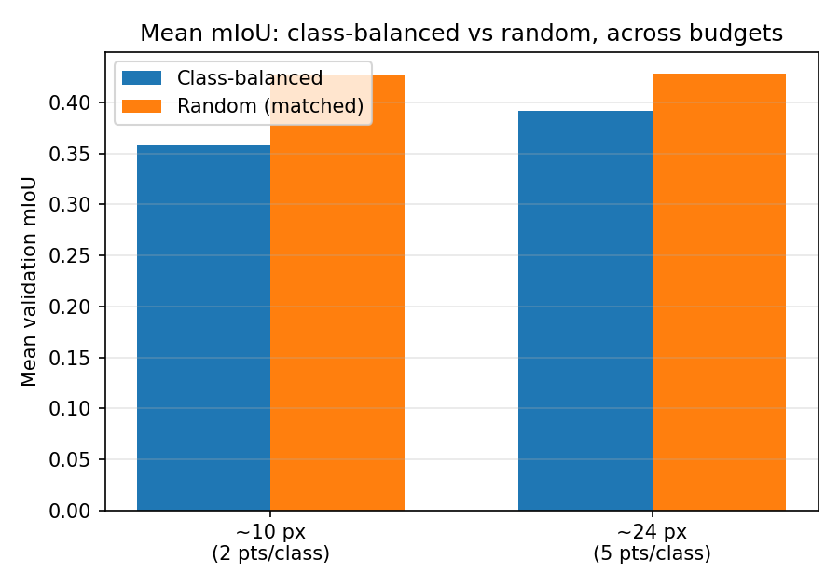

Discussion
The results only partially support the original hypothesis, and reveal a more nuanced picture than expected:
- Random sampling outperformed class-balanced sampling on mean mIoU at both budget levels (0.428 vs 0.392 at moderate budget; 0.427 vs 0.358 at tight budget), and the gap was larger, not smaller, at the tighter budget — the opposite direction from the original hypothesis.
- The effect is driven almost entirely by dominant classes (background, agriculture, water), where random sampling wins by a wide margin at both budgets. This is consistent with random sampling allocating points roughly proportional to class area, giving large classes substantially more supervision than class-balanced sampling's fixed per-class cap allows.
- barren is the one class that consistently favors class-balanced sampling at both budgets (by 0.05 at moderate budget, 0.12 at tight budget) — plausibly because it is both rare and visually similar to other classes (bare soil vs. building/road surfaces), so it benefits disproportionately from guaranteed coverage.
- road did not show a meaningful advantage for either strategy at either budget (differences of +0.013 and -0.001), suggesting its difficulty is more likely related to its thin, elongated geometry — which a standard cross-entropy-trained U-Net is known to struggle with — than to annotation strategy.
The original hypothesis assumed random sampling would fail specifically by omitting rare classes. In practice, at both budgets tested (10 and 24 points), most images still received at least one point on most classes over the course of many training images and epochs, so the rare-class "zero signal" failure mode was less severe than expected. The dominant effect instead came from class-balanced sampling capping supervision on large, easy classes, costing more mIoU on those classes than it gained on rare ones.

4. Conclusions & Next Steps
- Partial CE loss was implemented and verified correct: identical to standard cross-entropy under full supervision, with an analytic gradient matching a numerical check to ~1e-8, and exactly zero gradient at unlabeled pixels.
- A data-loading bug (bilinear mask interpolation during resize, corrupting class labels at boundaries) was identified and corrected before the reported experiments; results here reflect the corrected pipeline.
- Contrary to the initial hypothesis, random point sampling outperformed class-balanced sampling on overall mIoU at both tested budgets on real LoveDA data, driven mainly by better performance on dominant classes; class-balanced sampling's advantage was limited to specific rare/confusable classes such as barren.
- Suggested next steps: (1) test an even smaller budget (e.g. 1 point/class) where rare-class omission may become more severe for random sampling; (2) test a hybrid strategy — a small guaranteed minimum per class plus additional random points weighted toward larger classes; (3) run the point-density sweep (Experiment 1 design) on this real dataset to establish how much budget is needed before returns plateau, as was previously shown on synthetic data.

